Open Three-Segment Polygonal Shape
# Source: AI Source: Provided by: [Data Path: Persons Table -> ID Column: 1, Name_En Column: Motasem Essam] -> From: [ChatGPT] on [7/25/2026]
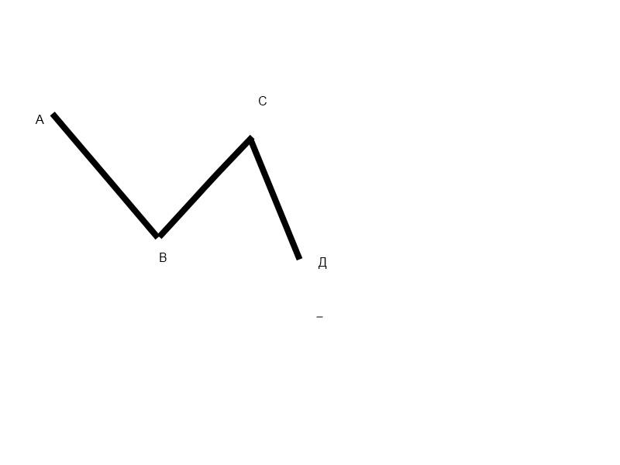
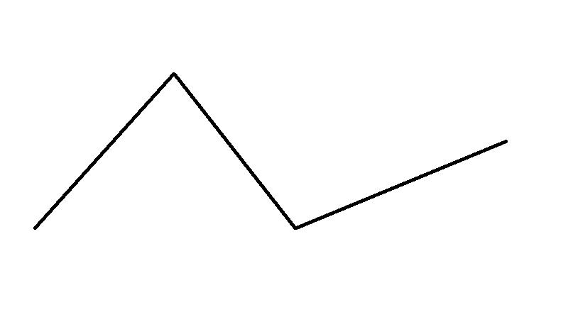
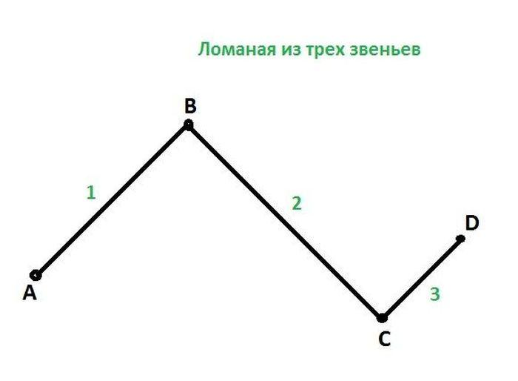
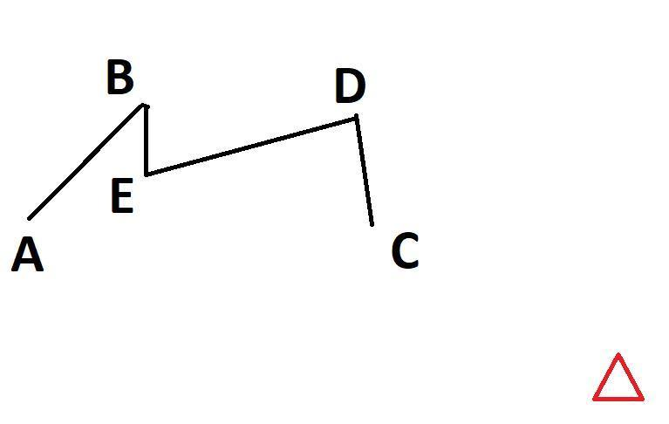
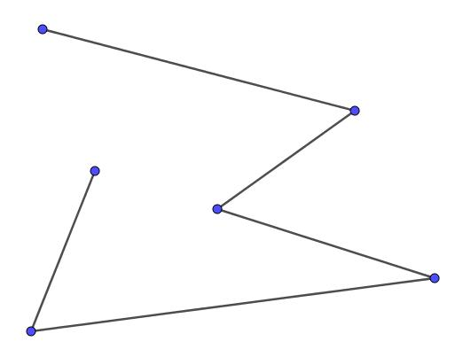

Definition
# Source: AI Source: Provided by: [Data Path: Persons Table -> ID Column: 1, Name_En Column: Motasem Essam] -> From: [ChatGPT] on [7/25/2026]
An Open Three-Segment Polygonal Shape is an open geometric figure formed by exactly three straight line segments connected end-to-end, where the final endpoint does not connect back to the starting point.
$$\boxed{\text{Open Three-Segment Polygonal Shape}3\text{ Straight Segments}+2\text{ Internal Vertices}+\text{Open Boundary}}$$
Unlike a triangle, it does not form a closed region.

Characteristics
# Source: AI Source: Provided by: [Data Path: Persons Table -> ID Column: 1, Name_En Column: Motasem Essam] -> From: [ChatGPT] on [7/25/2026]
An Open Three-Segment Polygonal Shape:
- Has exactly 3 straight line segments.
- Has 2 internal vertices where consecutive segments meet.
- Has 2 open endpoints.
- Does not enclose an area.
- Can bend in different directions.
- Can contain acute, right, obtuse, or straight angles.
- Can have equal or unequal segment lengths.
- Can be symmetric or asymmetric.
A useful representation is:
$$\boxed{A→B→C→D}$$
The missing segment $D→A$ is what prevents the figure from becoming a closed triangle.

Types of Open Three-Segment Polygonal Shapes

1. Open Zigzag Three-Segment Shape
# Source: AI Source: Provided by: [Data Path: Persons Table -> ID Column: 1, Name_En Column: Motasem Essam] -> From: [ChatGPT] on [7/25/2026]
The three segments change direction repeatedly, producing a zigzag path.
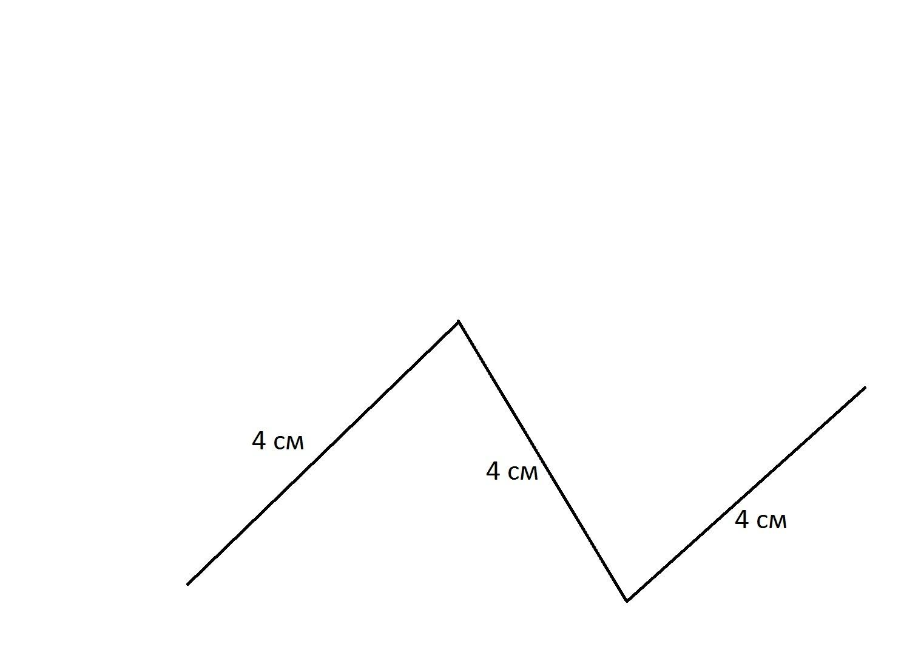
Example structure:
$$\boxed{A→B→C→D}$$
with alternating changes in direction.

2. Open U-Like Three-Segment Shape
# Source: AI Source: Provided by: [Data Path: Persons Table -> ID Column: 1, Name_En Column: Motasem Essam] -> From: [ChatGPT] on [7/25/2026]
Three segments form a U-like open path, with the two ends remaining open.
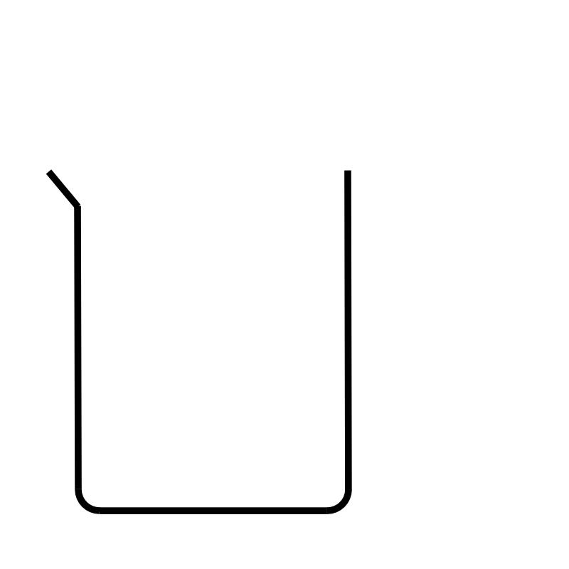
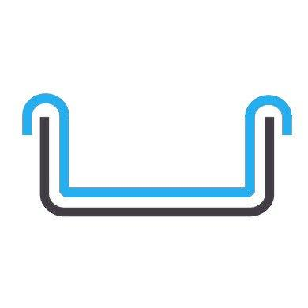
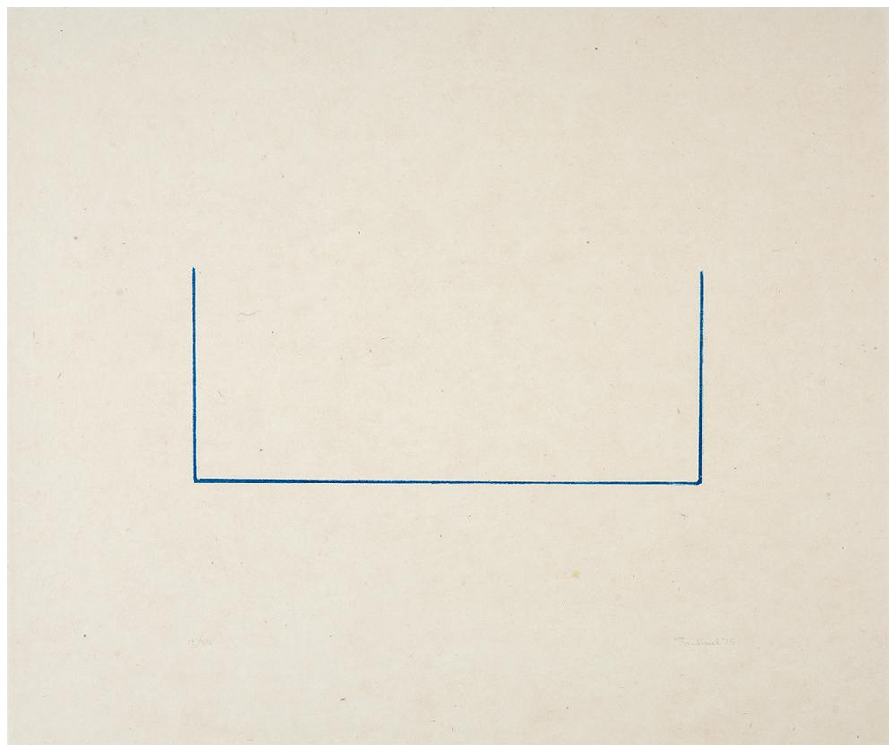
A common arrangement consists of:
- One vertical segment.
- One horizontal segment.
- One vertical segment.

3. Open C-Like Three-Segment Shape
# Source: AI Source: Provided by: [Data Path: Persons Table -> ID Column: 1, Name_En Column: Motasem Essam] -> From: [ChatGPT] on [7/25/2026]
Three segments form a C-like open polygonal path.
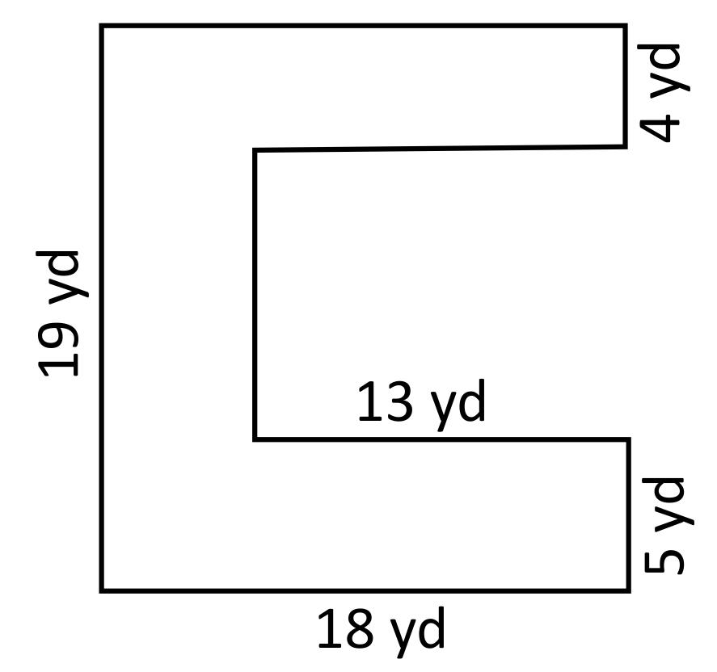
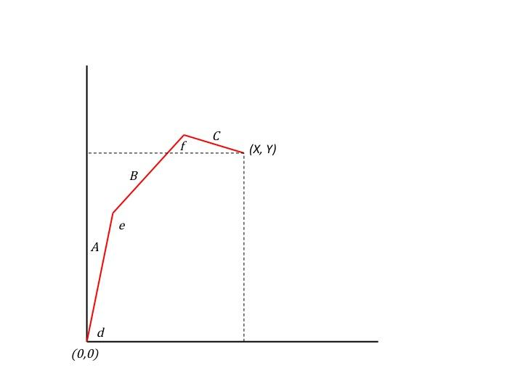
The two endpoints remain separated.

4. Open Stair-Step Three-Segment Shape
# Source: AI Source: Provided by: [Data Path: Persons Table -> ID Column: 1, Name_En Column: Motasem Essam] -> From: [ChatGPT] on [7/25/2026]
The segments form a simple step-like path.
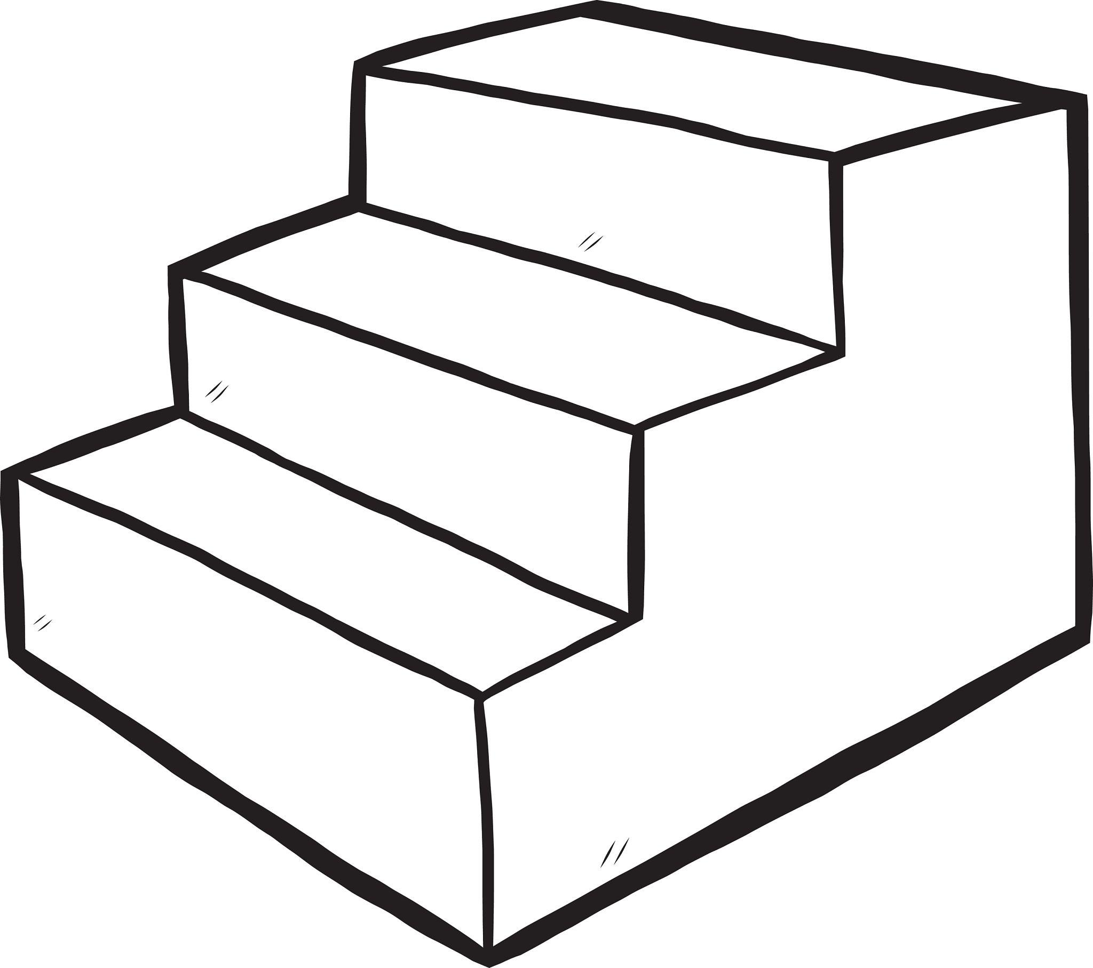
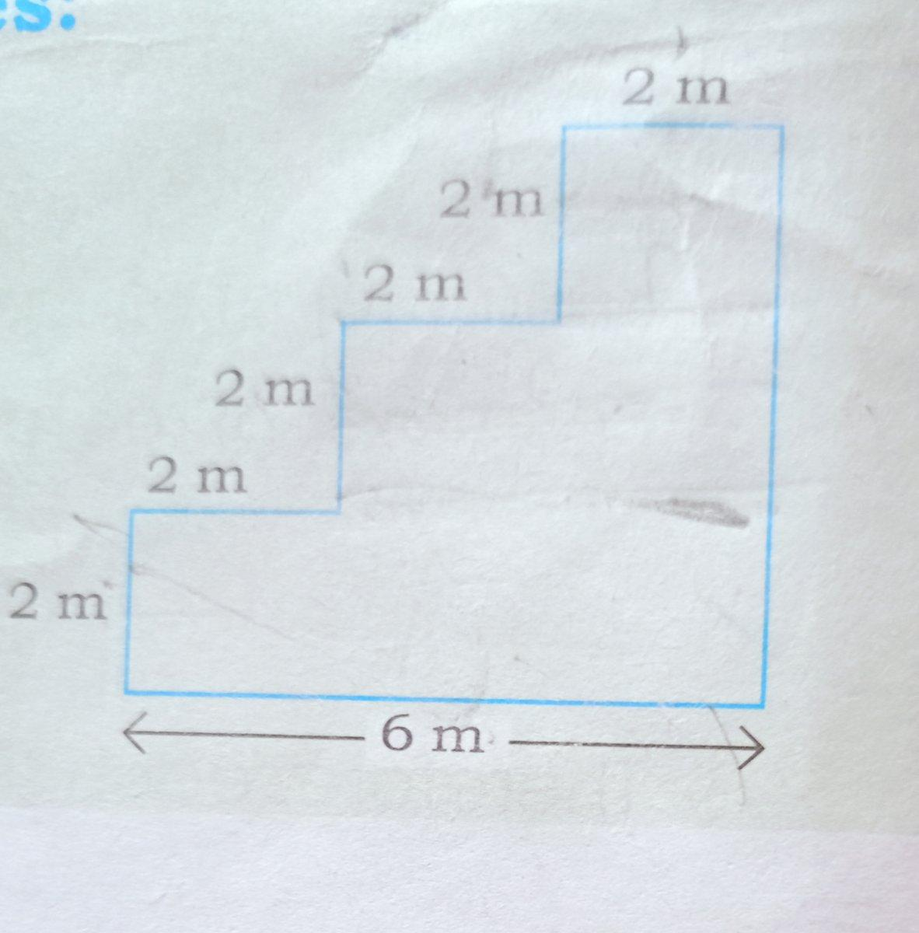
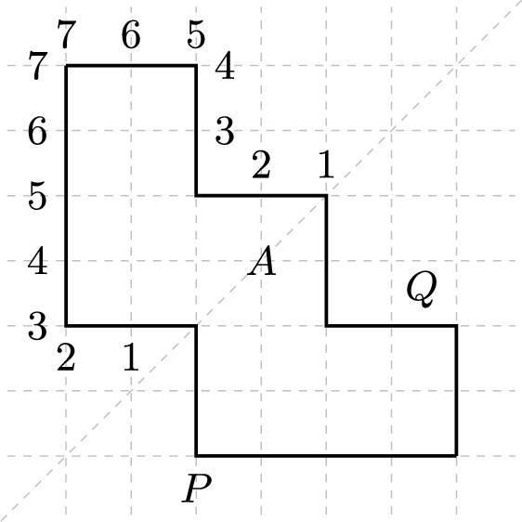
For example:
$$\boxed{\text{horizontal}→\text{vertical}→\text{horizontal}}$$

5. Open Acute-Angle Three-Segment Shape
# Source: AI Source: Provided by: [Data Path: Persons Table -> ID Column: 1, Name_En Column: Motasem Essam] -> From: [ChatGPT] on [7/25/2026]
At least one of the internal angles is acute.
$$0^{∘}<θ<{90}^{∘}$$
The figure remains open regardless of its internal angle values.

6. Open Right-Angle Three-Segment Shape
# Source: AI Source: Provided by: [Data Path: Persons Table -> ID Column: 1, Name_En Column: Motasem Essam] -> From: [ChatGPT] on [7/25/2026]
At least one pair of consecutive segments meets at a right angle.
$$\boxed{θ={90}^{∘}}$$
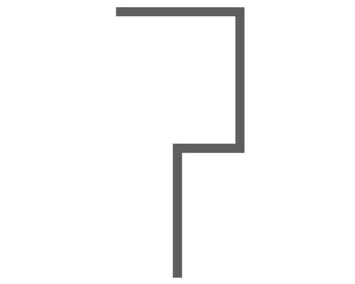
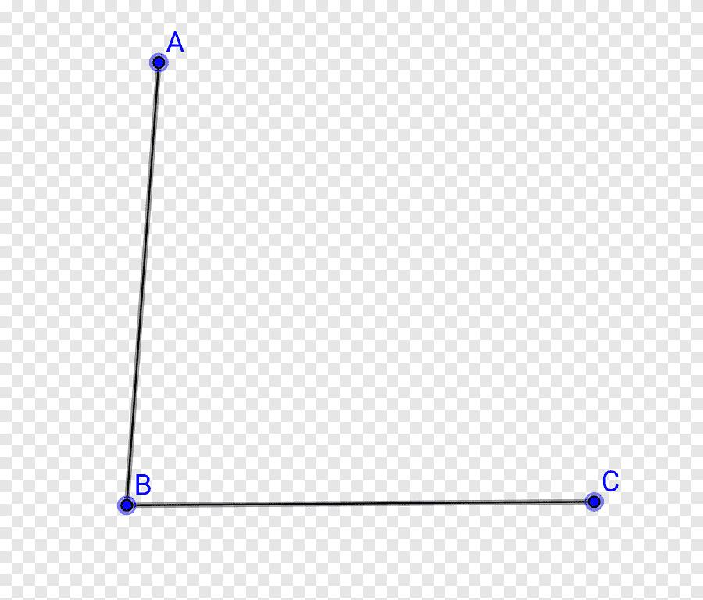

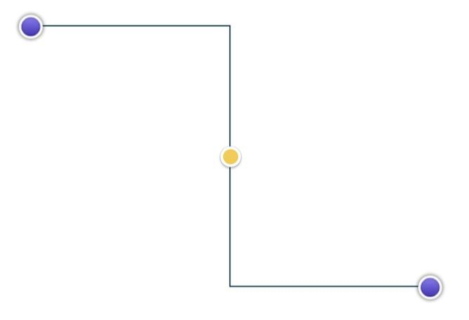
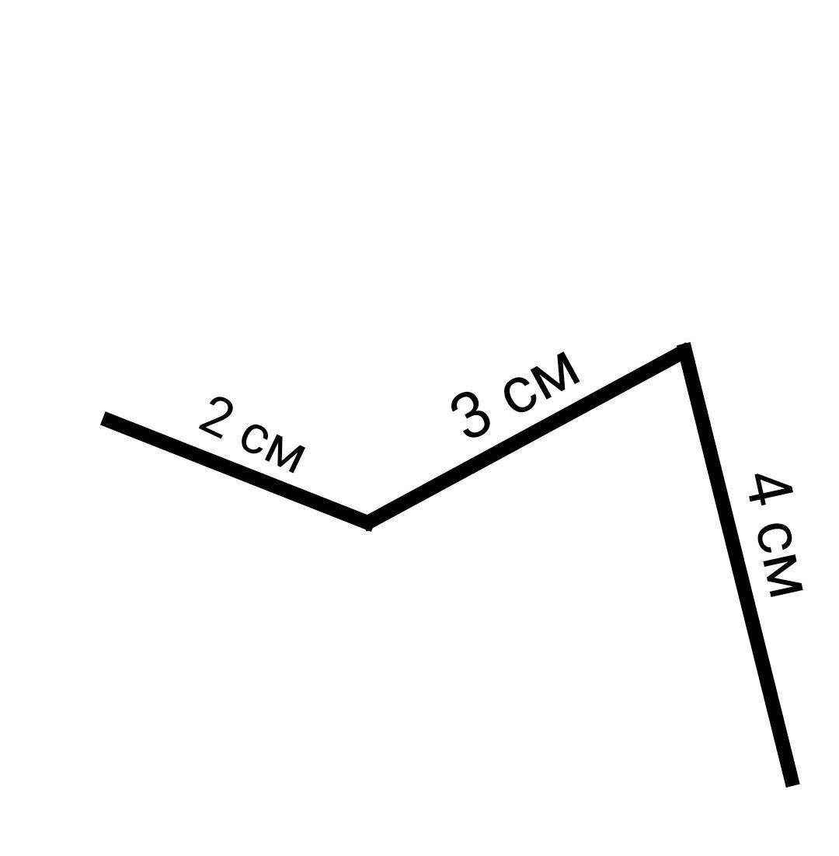
A U-like or stair-step arrangement can contain two right angles.

7. Open Obtuse-Angle Three-Segment Shape
# Source: AI Source: Provided by: [Data Path: Persons Table -> ID Column: 1, Name_En Column: Motasem Essam] -> From: [ChatGPT] on [7/25/2026]
At least one internal angle is obtuse.
$${90}^{∘}<θ<{180}^{∘}$$
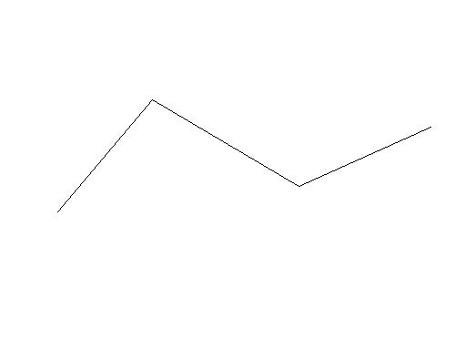
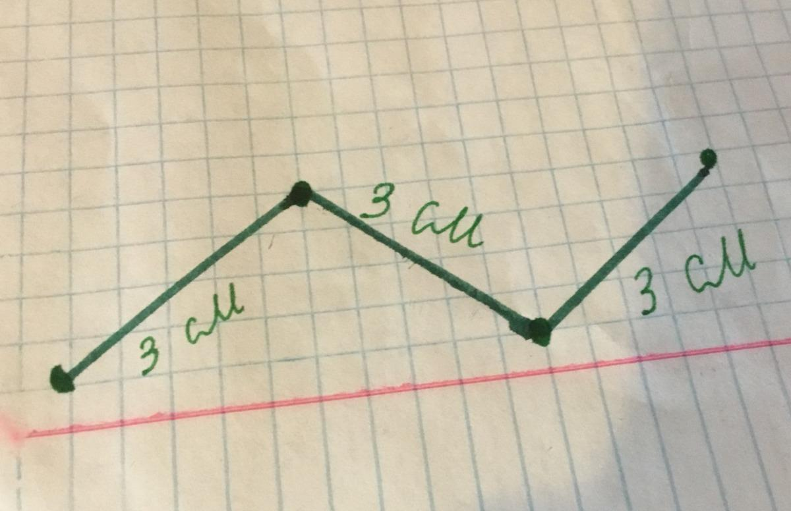

8. Open Straight Three-Segment Shape
# Source: AI Source: Provided by: [Data Path: Persons Table -> ID Column: 1, Name_En Column: Motasem Essam] -> From: [ChatGPT] on [7/25/2026]
One or more consecutive segments are collinear.
$$\boxed{θ={180}^{∘}}$$
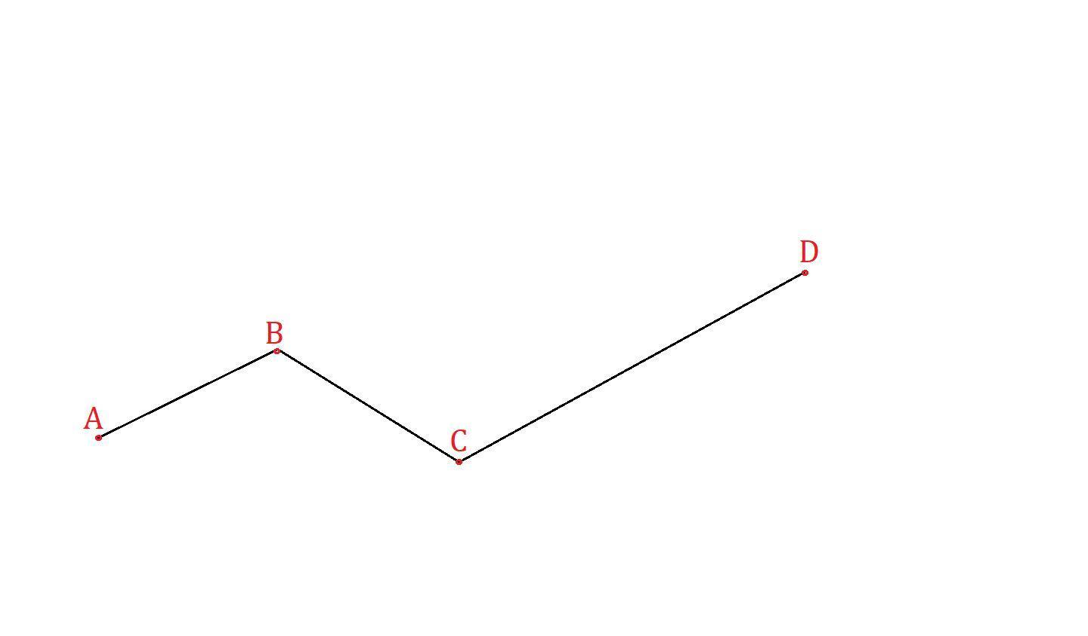
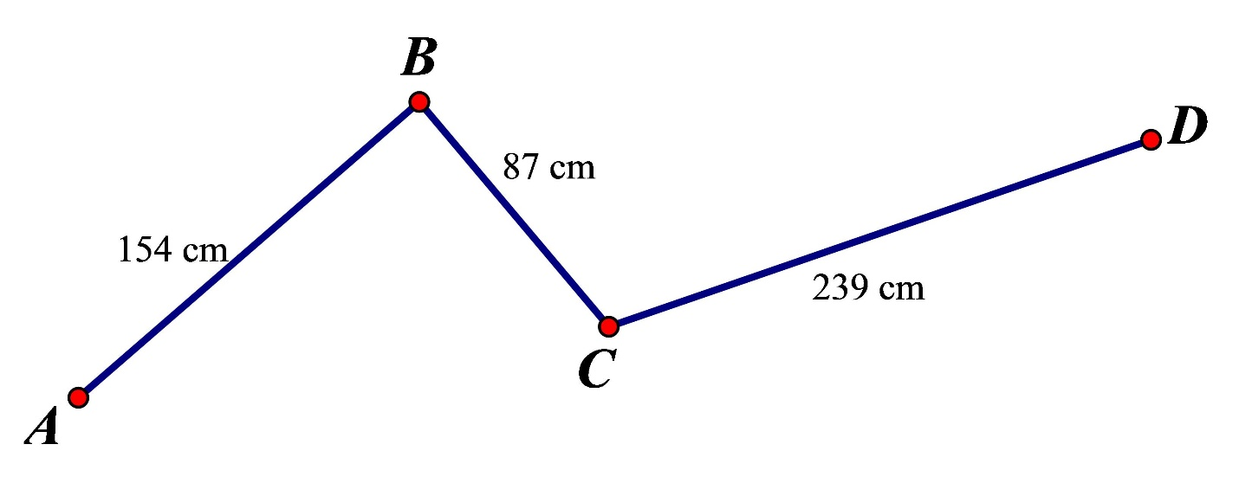
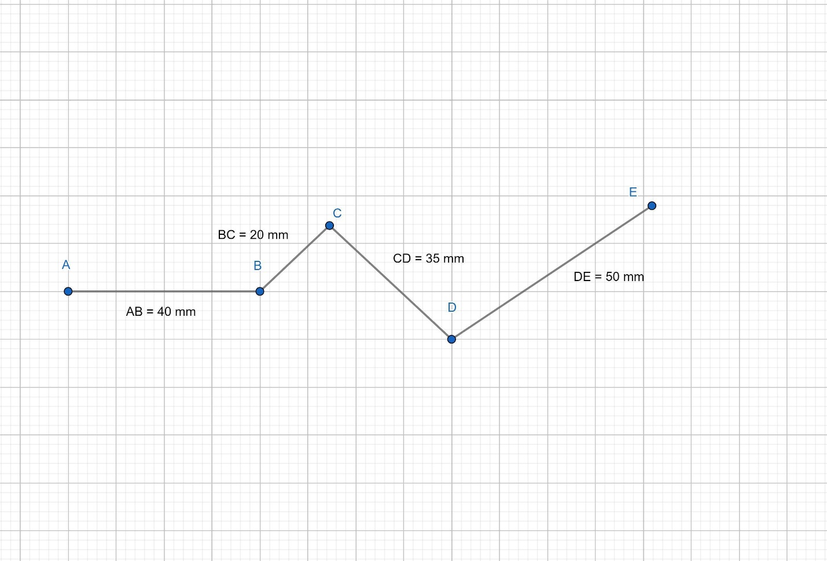
If all three segments are collinear, the figure appears as one straight path divided into three segments.

9. Equal-Segment Open Three-Segment Shape
# Source: AI Source: Provided by: [Data Path: Persons Table -> ID Column: 1, Name_En Column: Motasem Essam] -> From: [ChatGPT] on [7/25/2026]
All three segments have equal lengths:
$$\boxed{L_{1}=L_{2}=L_{3}}$$
Equal segment lengths do not make the figure a triangle because the boundary is still open.

10. Unequal-Segment Open Three-Segment Shape
# Source: AI Source: Provided by: [Data Path: Persons Table -> ID Column: 1, Name_En Column: Motasem Essam] -> From: [ChatGPT] on [7/25/2026]
The three segments have different lengths:
$$\boxed{L_{1}≠L_{2}≠L_{3}}$$
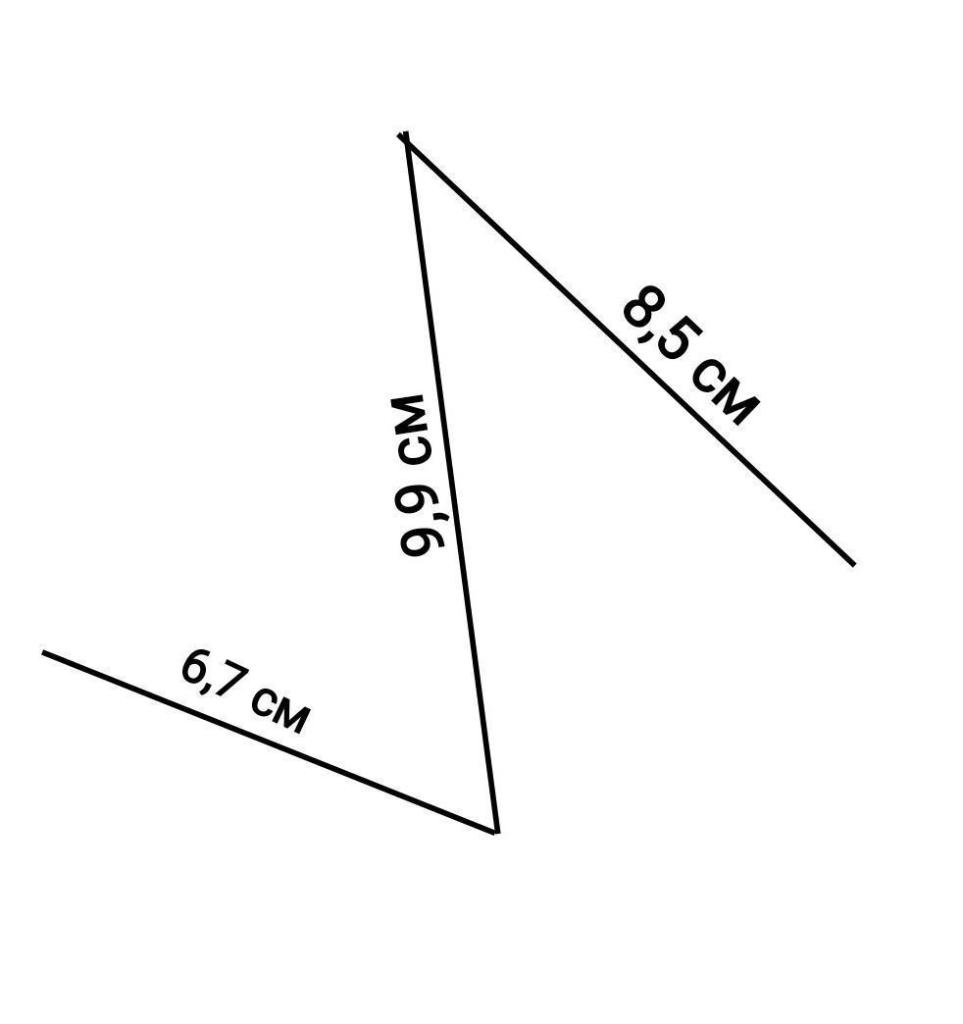
This is the more general irregular form.

Classification by Internal Angles
# Source: AI Source: Provided by: [Data Path: Persons Table -> ID Column: 1, Name_En Column: Motasem Essam] -> From: [ChatGPT] on [7/25/2026]
The two internal vertices allow two turning angles to be considered.
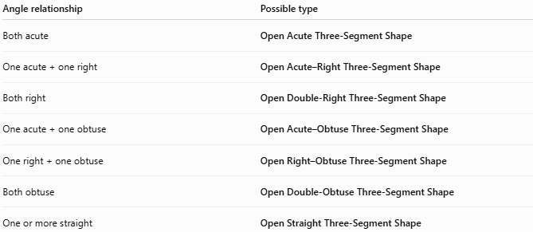
Angle relationship | Possible type
Both acute | Open Acute Three-Segment Shape
One acute + one right | Open Acute–Right Three-Segment Shape
Both right | Open Double-Right Three-Segment Shape
One acute + one obtuse | Open Acute–Obtuse Three-Segment Shape
One right + one obtuse | Open Right–Obtuse Three-Segment Shape
Both obtuse | Open Double-Obtuse Three-Segment Shape
One or more straight | Open Straight Three-Segment Shape
These angle classifications describe the turning behavior of the path, not polygon classification in the strict sense.

Open Three-Segment Shape vs. Triangle
# Source: AI Source: Provided by: [Data Path: Persons Table -> ID Column: 1, Name_En Column: Motasem Essam] -> From: [ChatGPT] on [7/25/2026]
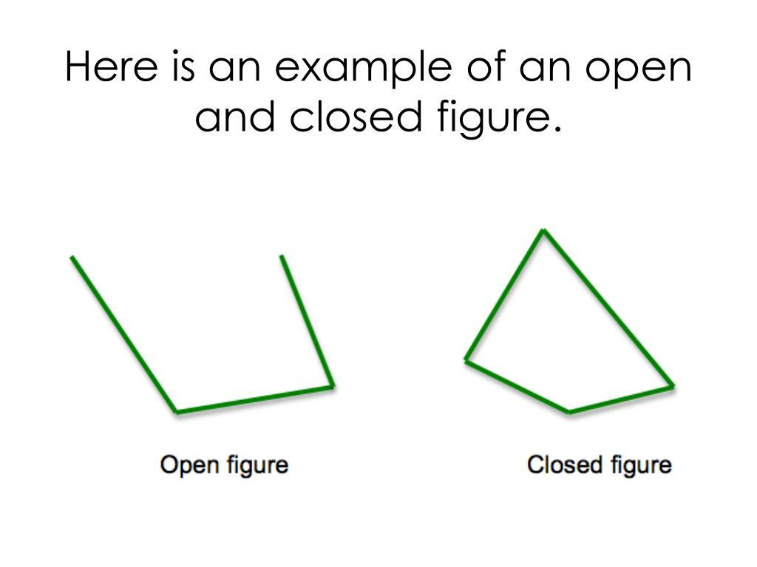
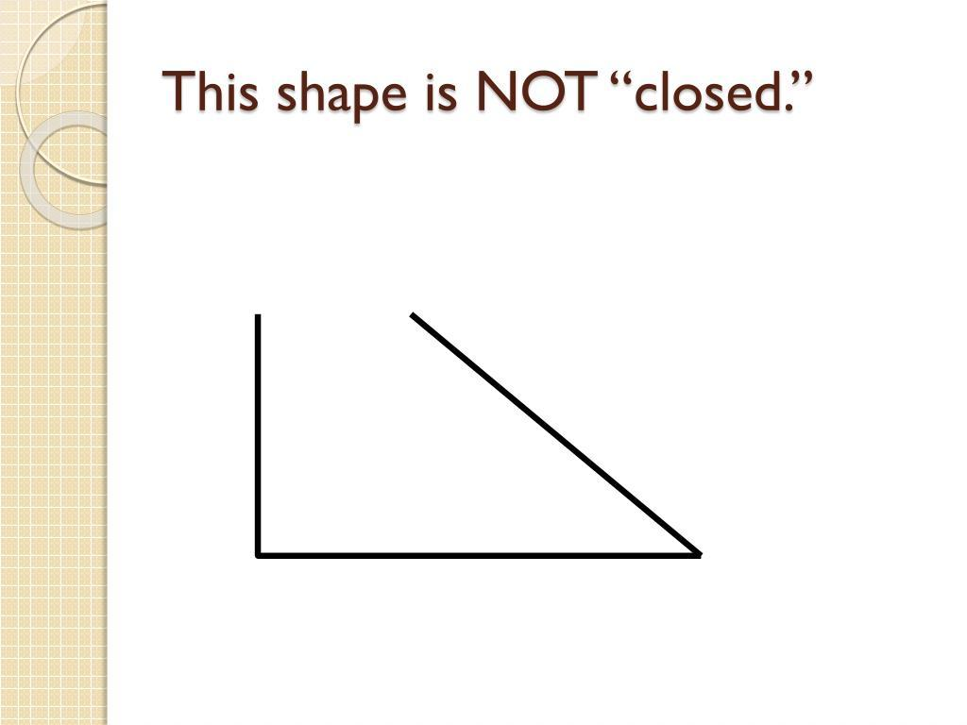
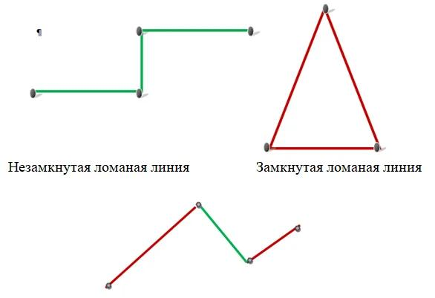
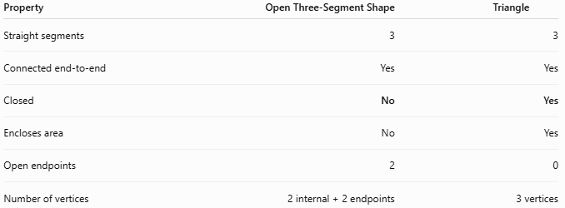
Property | Open Three-Segment Shape | Triangle
Straight segments | 3 | 3
Connected end-to-end | Yes | Yes
Closed | No | Yes
Encloses area | No | Yes
Open endpoints | 2 | 0
Number of vertices | 2 internal + 2 endpoints | 3 vertices
The crucial difference is closure:
$$\boxed{A→B→C→D}$$
is open, whereas:
$$\boxed{A→B→C→A}$$
is a triangle.

Area and Perimeter
# Source: AI Source: Provided by: [Data Path: Persons Table -> ID Column: 1, Name_En Column: Motasem Essam] -> From: [ChatGPT] on [7/25/2026]
Area
Because the figure is open:
$$\boxed{\text{No enclosed area}}$$
Therefore, it should not normally be assigned an area.
Total Length
The total length of the three-segment path is:
$$\boxed{L=L_{1}+L_{2}+L_{3}}$$
where $L_{1},L_{2},L_{3}$ are the three segment lengths.

Key Points
# Source: AI Source: Provided by: [Data Path: Persons Table -> ID Column: 1, Name_En Column: Motasem Essam] -> From: [ChatGPT] on [7/25/2026]
An Open Three-Segment Polygonal Shape is:
$$\boxed{3\text{ straight segments}+2\text{ internal vertices}+2\text{ open endpoints}}$$
It is an open polygonal path, not a polygon in the strict mathematical sense, because it does not close.

Conclusion
# Source: AI Source: Provided by: [Data Path: Persons Table -> ID Column: 1, Name_En Column: Motasem Essam] -> From: [ChatGPT] on [7/25/2026]
Open Three-Segment Polygonal Shapes are formed by connecting three straight line segments end-to-end without connecting the final endpoint back to the starting point. They can appear as zigzags, U-like paths, C-like paths, stair-step paths, or angle-based configurations. They can also be classified according to their segment lengths and internal angles. The defining property remains that the path has three straight segments but an open boundary.

